Assignment 1

Que 1. Write a Java program that checks if a predefined number is positive using an if-else statement and prints the appropriate message.
Ans:
class Possitive{
public static void main(String[] args){
int a=4;
if(a>0) {
System.out.println("The number is positive");
}
else{
System.out.println("The number is Negative");
}
} }

Output:
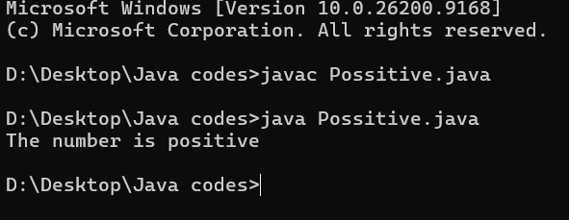

Que 2. Write a Java program that checks if a predefined number is negative using an if-else statement and displays the result.
Ans:

class Negative {
public static void main(String[] args) {
int n= 4;
if(n<0) {
System.out.println("the number is negative");
}
else {
System.out.println("the number is Positive");
}
}}

Output:

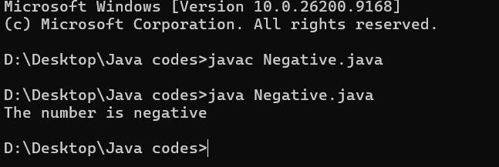

Que 3. Write a Java program that checks if a predefined number is odd or even. Use an if-else statement and the modulus operator (%) to determine whether the number is divisible by 2 or not.
Ans:

class EvenOdd {
public static void main(String [] args){
int num=10;
if(num%2==0){
System.out.println("The given number is even");
}
Else {
System.out.println("The given number is Odd");
}
}}

Output:

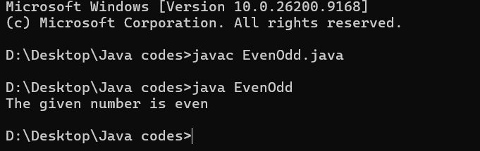

Que 4. Write a Java program that displays a "Good Morning" message if the predefined time is between 5 AM and 12 PM. Use an if statement to implement the logic.
Ans:

class Time {
public static void main (String [] args) {
int time = 11; // use 24 hour format
if (time >= 5 && time < 12) {
System.out.println("It's a good morning");
}
else {
System.out.println("It's a good afternoon");
}
}
}

Output:

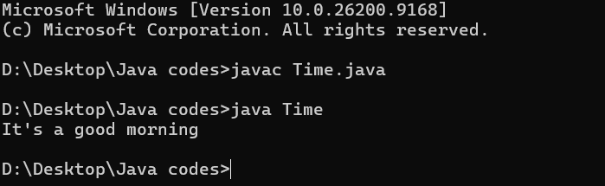

Que 5. Write a Java program that calculates the area of a square using the formula area = side * side. Use a predefined side length.
Ans:

class Square {
public static void main(String [] args){
int side= 4;
int Area= side*side;
System.out.println("Area of a square is:" + Area);
}
}

Output:
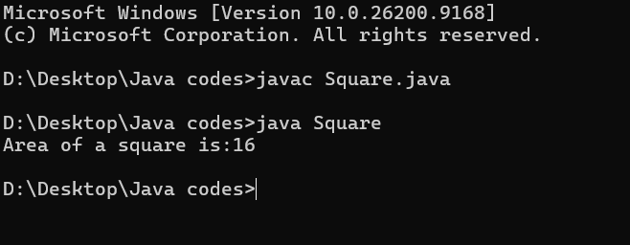

Oue 6. Write a Java program that calculates the area of a rectangle using the formula area = length * width. Use predefined values for length and width.
Ans:

class RectSquare {
public static void main(String [] args){

int L= 4;
int B= 5;
int Area = L*B;
System.out.println("The area of a rectangle is:" + Area);
}
}

Output:

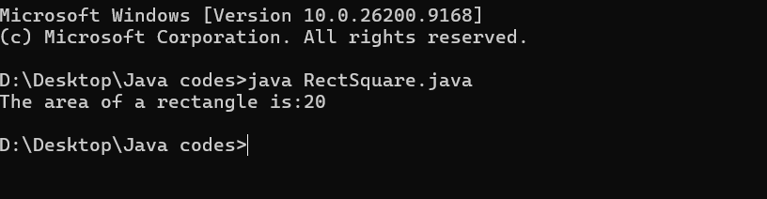

Que 7. Write a Java program that finds and prints the largest of three predefined numbers using if-else statements.
Ans:
class GreatNum {
public static void main(String [] args){
int a=5;
int b= 6;
int c= 11;
if(a>b && a>c)
{
System.out.println("a is greater");
}
else if(b>a && b>c)
{
System.out.println("b is greater");
}
else if(c>a && c>b)
{
System.out.println("c is greater");
}}}
Output:
